MET CS 625 -TERM PROJECT

Shrijana Phuyal KC

Boston University

Professor: Scot Arena

Facilitator: David Fortier

Table of Contents

Area 1: A Definition of an Organization (10 pts) 2

Organization Definition 2

The primary business or purpose of the organization 3

The primary kinds of employees within the organization 3

Physical Infrastructures 4

Figure 1-1 6

Figure 1-2 7

Building 3: Inpatient, Surgery 7

First Floor Layout: 8

Figure 1-3 8

Second Floor Layout: 9

Figure 1-4 9

Building 3: Outpatient, Pharmacy 9

First Floor Layout: 9

Figure 1-5 10

Second Floor Layout: 11

Figure 1-5 11

Area:2 Application Requirement 11

The name and purpose of the application 12

Application architecture details 13

N tier architecture: 13

Figure 1-6 14

A description of the typical user 14

The way a typical user uses the application (use case) 14

Figure 1-7 15

Real world requirements for the application 15

Area 3 : Local Area Network Design (20 points) 16

Conceptual Network Diagrams 16

Building 3 floor 1 16

Figure 1-8 16

Building 3 Second Floor 18

Figure 1-9 18

Building 2 First Floor 19

Figure 1-10 19

Building 2 Second Floor 20

Figure 1-11 20

Justification of Diagrams 20

Area 4: Local Backbone Network Design (20 points) 22

Local Backbone Network Design 22

Figure 1-12 22

Textual description for the backbone network 22

Figure 1-13 24

Area 4-1: WAN Backbone Network Design (15 points) 24

Figure 1-14 24

Figure 1-15 25

Area 5: Network Security and Management (10 points) 26

Management 27

IP Address and Network Card Issue: 27

Damage hardware 28

Firewall Status 28

Slow Connection 28

No network Access: 28

Reference: 30

Area 1: A Definition of an Organization (10 pts)

## Organization Definition

Since it was founded in 1999, Banner health aims to give the best health care system in six states of United States. The headquarter is located in Phoenix, Arizona). It has 28 hospitals, and few specialize facilities This hospital is also known as one of the largest employers in United State having more than 50,000 employees which is also a leading non-profit health care provider. The most important goal of Banner Health is to “make health care easy to make life better”. Banner health provide services like physician services, hospice and home care service and they also offer specialized services at the following banner health care institute:

• Banner Alzheimer's Institute

• Banner Concussion Center

• Banner Heart Hospital

• Banner MD Anderson Cancer Center

• Banner Children's

• Banner CORE Center for Orthopedics

• Western States Burn Center

## The primary business or purpose of the organization

Banner Health is a non-profit healthcare organization which carries the mission of providing one the best health care in the nation. The hospital provides the services like Academic Medicine, Alzheimer’s, Cancer, heart, Maternity, Orthopedics, Pharmacy, Pediatrics, Physicians and specialist, Research, Urgent care and Women’s Health. Banner health care mainly focuses on continuity providing excellent patient care and innovation and it has been nationally recognized for one of the top Five Health systems in the U.S.

## The primary kinds of employees within the organization

The primary kinds of an employee in the Hospital Include Doctors, Nurses, Allied health professionals, business professions and other hospital staffs. Doctors consist of the consultant, the registrar and the resident. Different roles of nurse include the nurse practitioners, associate nurse, and registered nurses. Allied health professionals include dietitians, occupational therapists, pharmacists, physiotherapists, podiatrists, physical therapists, the business professionals include lawyers, analyst, human resources, IT professionals and the other hospital's staff includes clinical assistant, patient services assistant, porters, volunteers, ward clerks etc.

Hospital patients are the primary kind of the customers.

## Physical Infrastructures

Banner Health operate in six States with 28 hospitals including three academic medical centers.

1. Arizona

* Banner Payson Medical Center
* Banner University Medical Center Phoenix
* Banner Desert Medical Center
* Cardan Children’s Medical Center
* Banner Behavior Health
* Banner Herat Hospital
* Banner Baywood Medical Center
* Banner Gateway Medical Center/Banner MD Anderson Cancer Center
* Banner Goldfield Medical Center
* Banner Ironwood Medical Center
* Banner Casa Grande Medical Center
* Banner -University Medical Center Tucson
* Diamond Children’s Medical Center
* University of Arizona Cancer Center
* Banner- University Medical Center South
* Banner Boswell Medical Center
* Banner Del Webb Medical Center
* Banner Estrella Medical Center
* Page Hospital

1. California

* Banner Lassen Medical Center

1. Nevada

* Banner Churchill Community Hospital

1. Nebraska

* Ogallala Community Hospital

1. Wyoming

* Washakie Medical Center
* Platte Country Memorial Hospital
* Community Hospital

1. Colorado

* Sterling Regional Medical Centre
* East Morgan Country Hospital
* North Colorado Medical Center
* Banner Fort Collins Medical Center
* McKee Medical Center
* Banner Health Clinic

Banner Health Nationwide Layout

### Figure 1-1

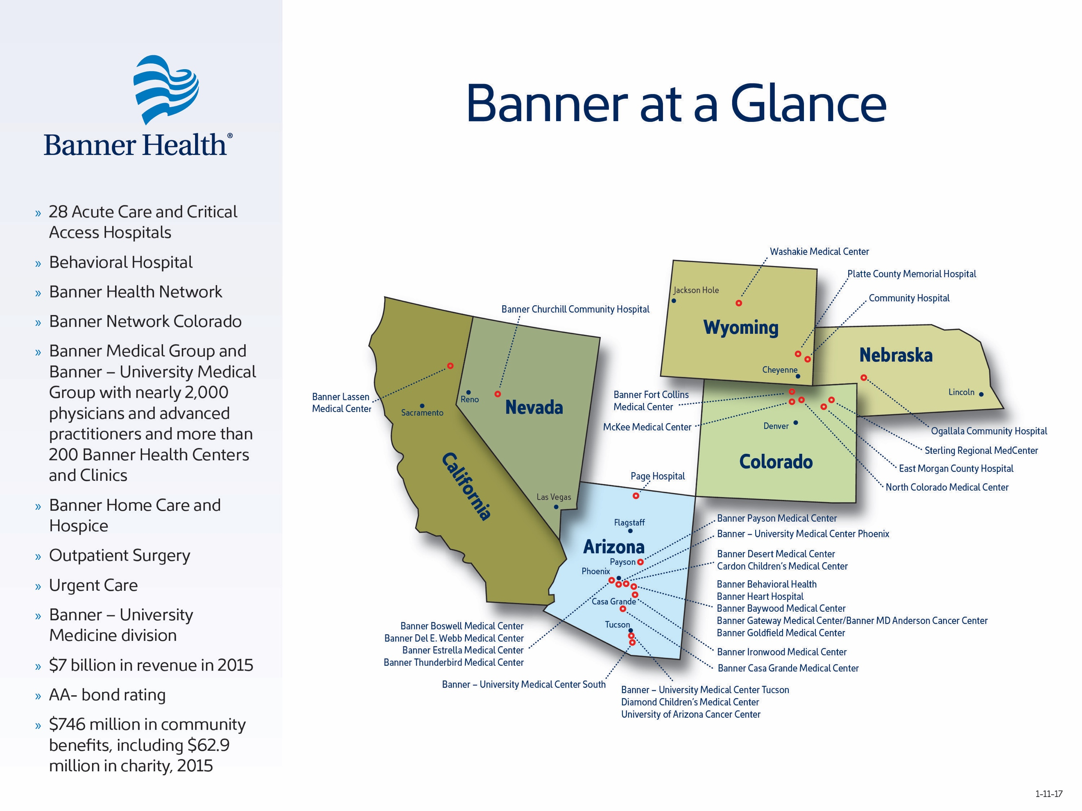

#### 

Banner Health Clinic is located at 1405 S 8th Ave #101, Sterling, CO 80751.Service provided at this location is Endocrinology, family medicine, Family Nurse Practitioner, Internal Medicine, Orthopedics, Surgery, Critical Care, Urology and Pulmonary and Asthma. (Health B (2018)) This Campus has three Buildings. The distance between Building 2 and Building 3 is 433.36 feet, the distance between Building 1 and building 3 is 46.37 feet and the distance between building1 and building 2 is 46.37 feet as well. The three buildings are connected by Bridge.

Diagram of Banner Health Clinic

### Figure 1-2

Building 1

Main Building, Administration

Building 2

Endocrinology, Critical Care, Outpatient, Pharmacy

Building 3

Inpatient, Surgery,

## Building 3: Inpatient, Surgery

Width: 350 ft, Length:130 ft

Number of Floor:5

### First Floor Layout:

### Figure 1-3

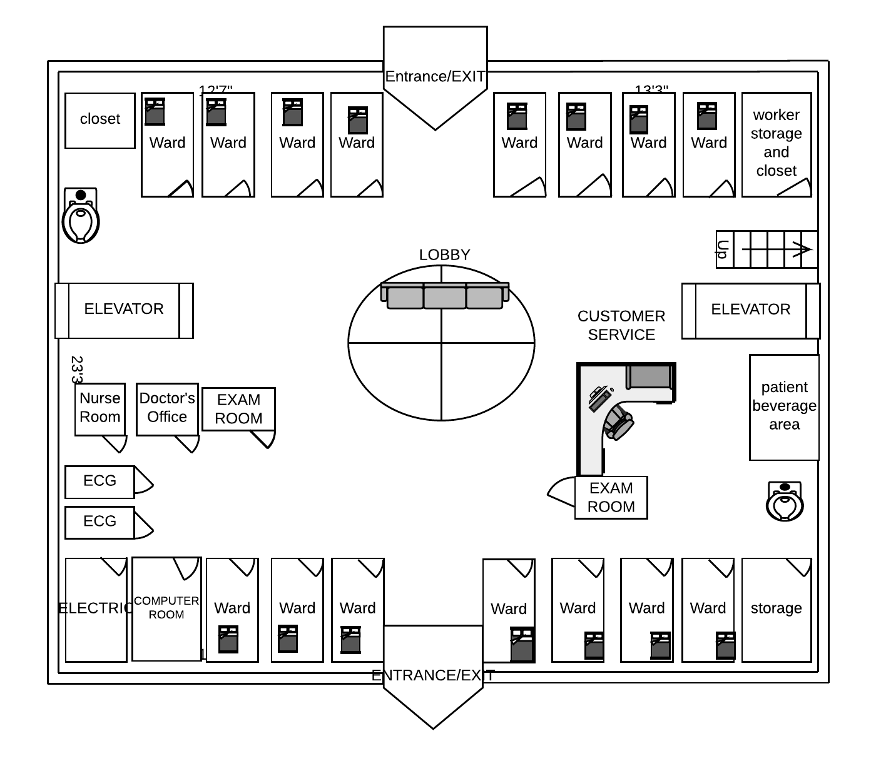

In the first floor of the building there are two exists. There are wards in two opposite sides of the floor. There are all together 25 computers and three printers in the first floor. The floor has two elevator and a stair and one of the elevator can also be used for the parking entrance. There are two public restrooms with private restroom in each ward including doctor’s and nurse office.

### Second Floor Layout:

### Figure 1-4

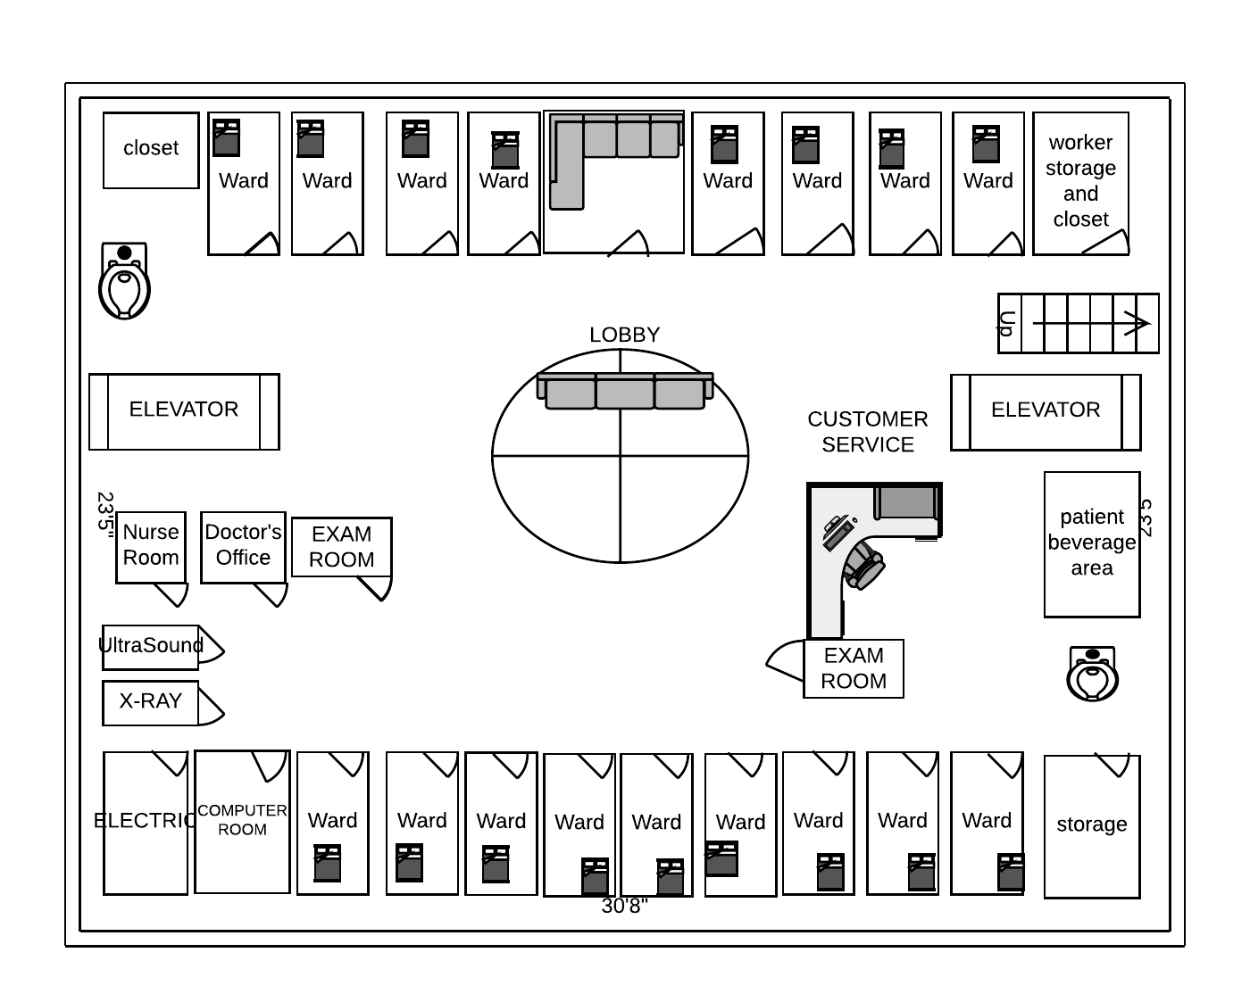

The first and second floor plan looks alike but the exit to outside the build id through the elevator or the stairs. There are

## Building 3: Outpatient, Pharmacy

### First Floor Layout:

Width: 300 ft, Length 170 ft

Number of Floor:3

### Figure 1-5

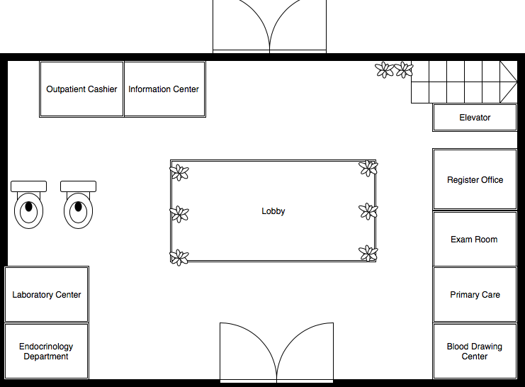

The first floor of the outpatient building is basically used for outpatient center where there is register office, primary care center and cashier as well as laboratory center located.

### Second Floor Layout:

### Figure 1-5

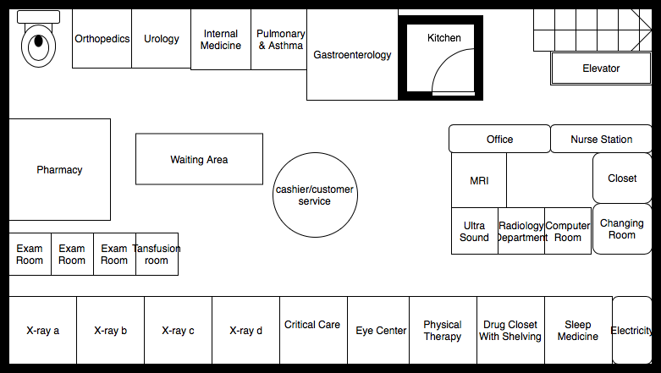

The second floor of the building 3 includes the outpatient pharmacy which provides the prescription refill, drop off and pick up facility. There are exam centers, x-ray room, physical therapy center, gastroenterology center located.

# Area:2 Application Requirement

Almost every health care system uses certain applications and those applications are widely accepted all over the world. These applications are making health care system reliable and and convenient for the providers as well as the patients. The hospital applications are very useful while sending and receiving the clinical, administrative data. These applications are also useful for interchanging image such as X-ray and ultrasounds. Following are some of the applications:

## The name and purpose of the application

Laboratory Information Management system: Laboratory Information Management system also known as (LIMS) is used to manage the workflows and manage the sample. Banner Health use LIMS for reliable and more quicker results. With the help of LIMS, the hospital can centralize the access of the control data which also support the compliance efforts as well as track and manage samples. The most important aspect of the LIMS is the quality control by storing all information in one place, preventing the use of expired lots, reduce human error in manual data entry, avoid costly mistakes.

Inpatient Administration System(IAS): Inpatient Administration system help in tracking the patient’s status and updating the status. Nurses with the help of IAS will be able to work with pre-admission process and track the patient’s care and communicate the update with doctor.

Out Patient Management System: Out Patient Management System goal is to get the patient’s accurate medical condition and to avoid the unnecessary surgical procedures.

Appointment Management System: Appointment Management system helps the clinic to get accurate information on the patient appointment schedule without overlapping with another appointment. With the appointment management system patient will also get reminder about their appointment two day before the appointment date.

E-prescription System: E-prescription provides sustainable advantage to the doctors and the patients as well. According to E-prescription have been used by 70% of the physicians in United States. E-prescription prevents from the handwritten errors and patient may also loose the paper prescription which also prevents of duplication of the dosages. (D. F. (n.d.).) There is a pharmacy located in one of the building of Banner Health so once a patient is prescribed with the medication, he/she don’t have to go to drop of the prescription or wait longer for the prescription but rather they can pick up the prescription directly from the pharmacy after being available.

Electronic health record System: This is used to record patient health information that includes patient prescription, patient billing, patient test results and drugs lists.

## Application architecture details

## N tier architecture:

Among the two-tier, three-tier and N-tier architecture Banner Health system uses the N tier architecture. The N tier architecture is any number of application where more than three sets of computers are used. In this tier, there is a better balance of the processing load which has scalability. N tier is suitable to support the enterprise level, security and fault tolerance. While comparing two tiers, three-tier and N tier architecture, the major advantage of N tier is that different servers which are available in N tier architecture balances the load and secure all the tier easily without interrupting one another. With n tier architecture the new technologies can be adopted without rewriting the application and there is less dependency of one layer to another. According to book, In this architecture the client is responsible for presentation logic, data base for server and data storage for application logic. The Figure shows an example of N-tier Architecture

### Figure 1-6

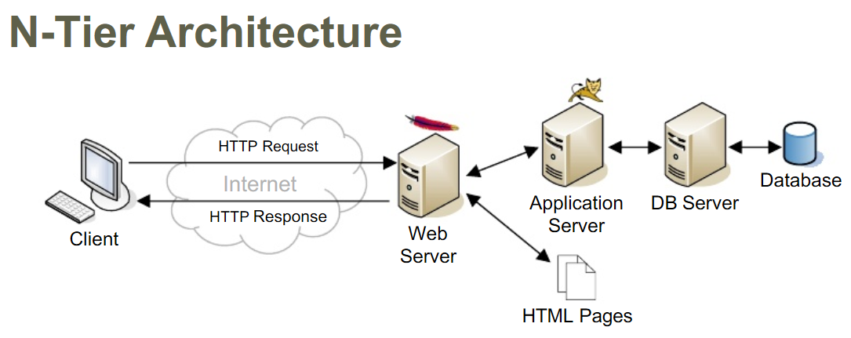

## A description of the typical user

The typical user of the application is the Employee of the clinic that includes the doctors, Surgeons, Nurses, pharmacists, laboratory and X-ray technician, radiology tech, Clerical staff, Information technology staff, Social Worker etc. Doctors uses the application for updating the patient medical information, for referring the patient to another physician. Patients uses the system to see their lab report, their billing information make or cancel the appointment and refill the prescription. The customer support clerk uses the application for receiving the call, making an appointment, helping the patient to communicate with their physician.

## The way a typical user uses the application (use case)

The first point of contact, the customer support representative access the system to see if the patient has an appointment or not. The representative collects the patient personal information such as full name, date of birth and the address along with the patient phone number. After they collect all the information they guide patient through the steps. The laboratory technician uses the system before and after drawing the patient blood. Once the result is back the technician upload the lab result to the database. Once the doctor meets the patient, he accesses the system to see the result from the lab. The doctor prescribes the medicine through the e-prescription and the pharmacist can see the list of drugs prescribed by the doctor.

### Figure 1-7

Use Case for Hospital Management System Between Patient, Receptionist and Doctor

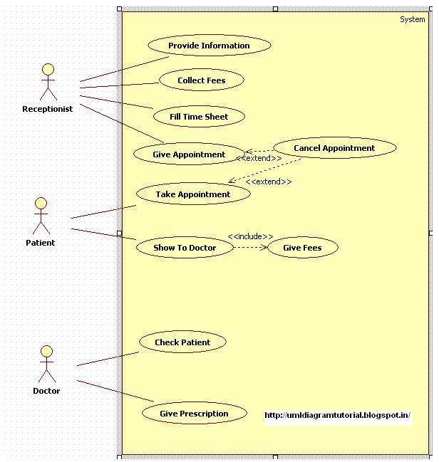

## 

## Real world requirements for the application

The hospital will have more and more mobile device connected to the network which is wireless. The hospital need to have faster and reliable internet bandwidth. The hospital will be using internet for different activities such as browsing the web, transferring data from one location to another, attaching the images from one building to another building. The doctors do video conferencing to get detailed information about the patients reports. In daily bases there could be the possible number of 5 Mbps of network consumed by the patient and employee of the hospital in each building. For transferring the data and image, it could consume 5 Mbps and little more for the video conferencing which could possibly be 7 Mbps and total internet consumed would be 17Mbps times the user, which could possibly be 2200 user altogether in all the building. Therefore, to support many various functions in hospital, it requires 37 Gbps bandwidth in all the building.

# Area 3 : Local Area Network Design (20 points)

## Conceptual Network Diagrams

### Building 3 floor 1

### Figure 1-8

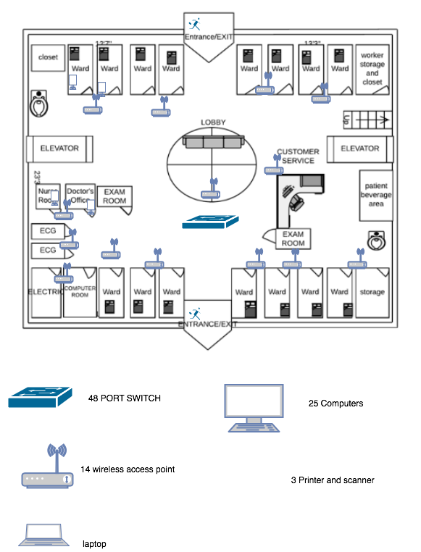

### Building 3 Second Floor

### Figure 1-9

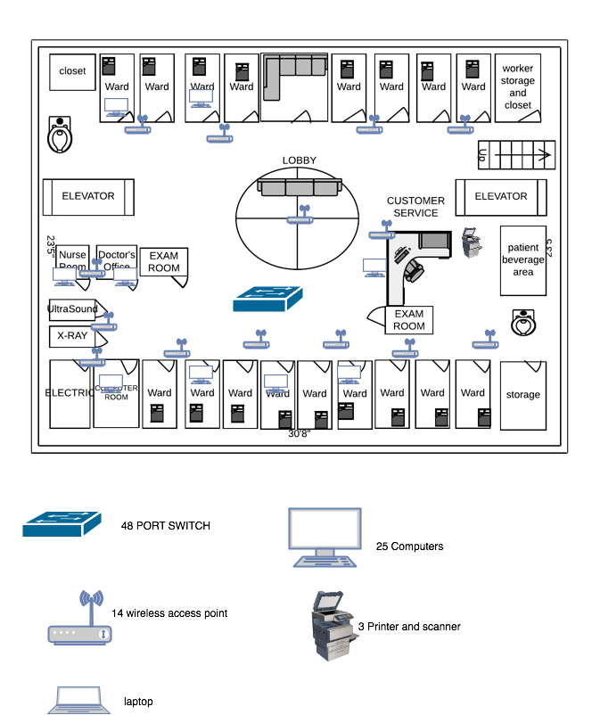

### Building 2 First Floor

### Figure 1-10

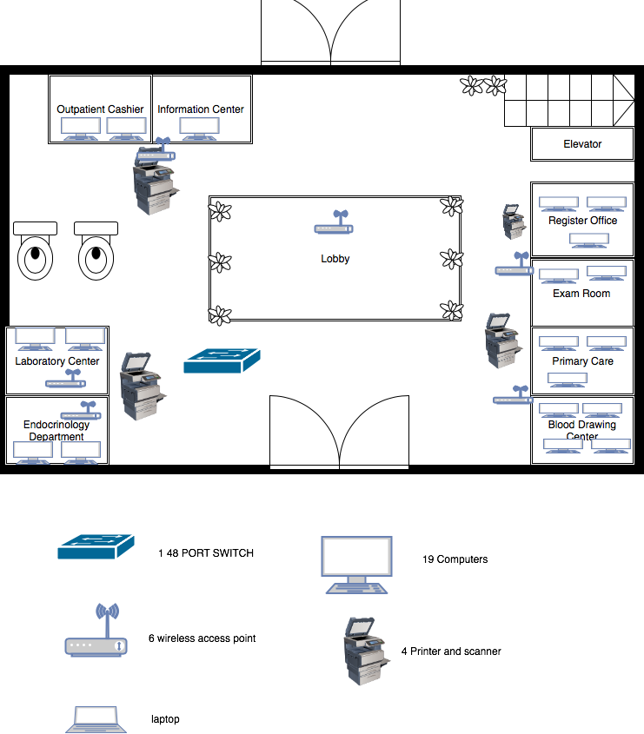

### Building 2 Second Floor

### Figure 1-11

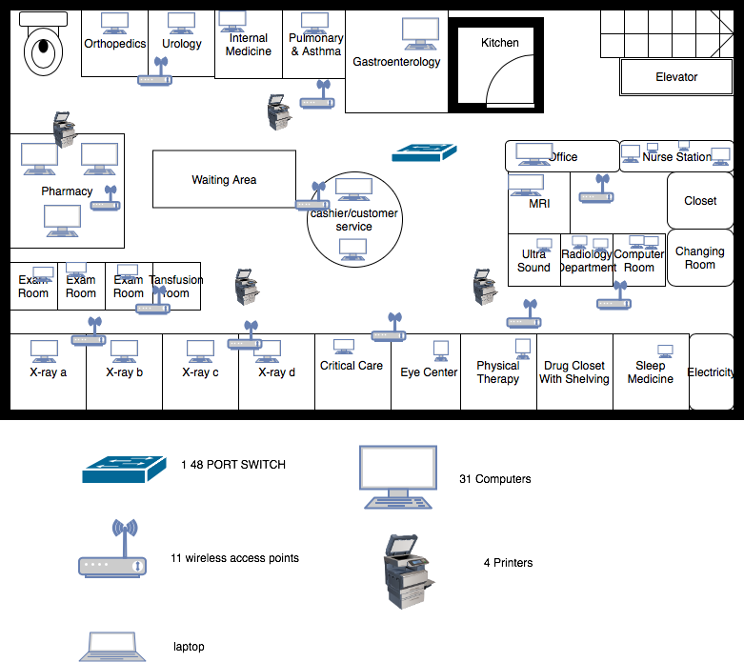

## Justification of Diagrams

There is higher user of network in hospital Industries and the hospital need to ensure that there is always reliable connection. The slight delay in network can always have negative impact. Banner Health clinic utilizes the wired and wireless connection. The backbone network is located at the lower level of the building and the other floor of get the network connection with the help of router and the cable. The computer available in all the floor are connected with wired as well as wireless for backup. Laptop available in the building are connected to internet through wireless. There is a self-serving kiosk located at the entrance of the hospital which is connected wireless. In the self-serving kiosk the patient and the visitor sign in before entering into the hospital which is located at the first floor in in each Banner health clinic building. The switched are connected through the Ethernet network. The access points are assigned for all different area of the hospitals and with different computer and laptops. The computers are connected wired as well as wireless. All the access point is connected to the switch. And to configure the router, the router is connected to the switch. As the whole network is in the same router so the IP address will be the same. Under one router there is only one Default Gateway which is the router IP address. CAT 5e cables are used here which can connect to switch. The reason behind choosing 48-port switch is that it maximizes the bandwidth. With the 48 10/100/1000 Mbps ports, it has the capability of providing 2000 Mbps of data in full-duplex mode. There are four optional fiber port which can connect to server and provide the service of uploading images and video conferencing in less time. It is even easier to use the web browser interface with the switch management and monitor the switch performance as well as configure ports. Banner health uses one switch in each floor to minimize the risk of having just one switch such as redundant sups, dual power etc.

Using Switch based ethernet is better than using hub based ethernet because switch based ethernet provide point to point circuits which means the circuit that connect with the switch is not shared with any other devices. (book)

The IP address of pc 1 is 192.168.1.2

Subnet Mask 255.255.255.0

Default Gateway is 192.168.1.1

# Area 4: Local Backbone Network Design (20 points)

### Local Backbone Network Design

### Figure 1-12

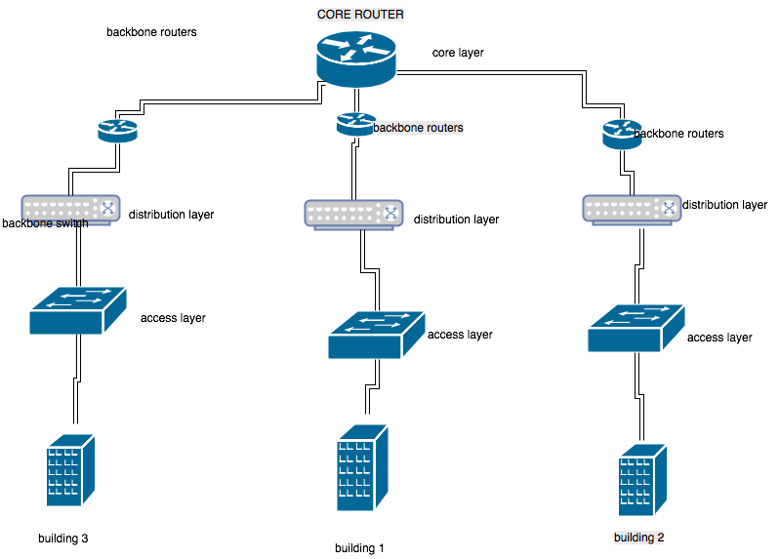

## Textual description for the backbone network

The Banner Health clinic with three building have a single core router which serve as a core layer that support the fast transport between distribution switches and provide the interconnectivity across the building. The core layer also provides the faster transport with the reliability. There is a backbone router that is connected with the core layer and the distribution layer. As shown in the diagram all three building consists of one distribution layer in each building. The distribution layer limits the connectivity between access layer and the core layer. Distribution layer also provide the redundancy and load balancing. The access layer which is connected with distribution layer provides the user access to the network. Each building has bunch of access layer connected with the switches (distribution layer). The benefits of having access layer is the high availability, port security. Each building consists of different LAN and therefore each LAN has a separate subnet which can be managed by a different entity. The benefit of having a separate subnet is that the routed backbones clearly segment each part of the network that is connected to the backbone and each part of the network has its own subnet address which can be managed separately as well as the data is regenerated indefinitely, and the broadcast traffic is prevented from moving between different networks.

The clinic is using star network topology in which the network components are connected to the central device switch with the point to point connection. According to Sparrow P in star topology all the computer is indirectly connected to every node.

The reason I used this topology is whenever the signal is sent, it reaches to the intended destination. Star topology is centralized management therefore the network can be monitored remotely and if any failure occurs, it is easy to detect it and troubleshoot it.

### Figure 1-13

s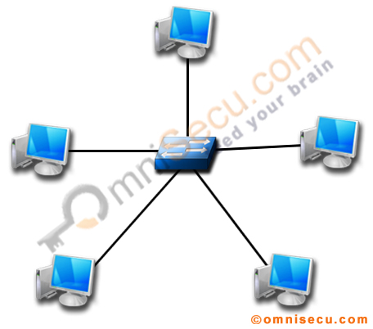

Star Topology

# Area 4-1: WAN Backbone Network Design (15 points)

Packet-switched service

LAN=local area network;

PAD= packet assembly/disassembly device

### Figure 1-14

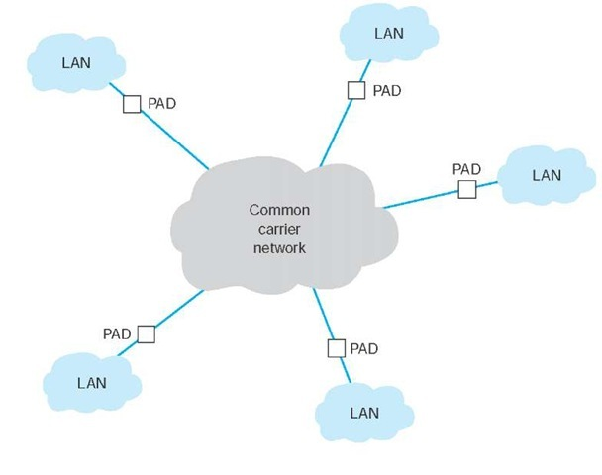

Wide Area Network Conceptual Network Diagram for Banner Health

### Figure 1-15

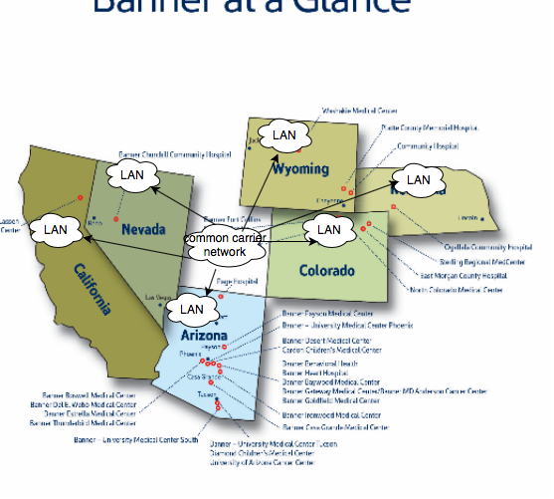

Among the three types of WAN service which is Dedicated -circuit, packet-switched service and the virtual private network service, the Banner Health is using the Packet Switched Network which operates like an Ethernet and IP network that is used in LANs and BNs (FitzGerald, J., Dennis, A., & Durcikova). The hospital chose the Packet-switched service because the connection can be bought into common carrier cloud by paying fixed fees for the connection. The big files are broken into smaller pieces called packet. The packets carry additional information about their sender information and their destination address therefore the packets are sequential send over the network. The computer with the help of packet assembly/disassembly device reassemble the pieces and send them through the packet-switched network. All the packet travels through the different root and at the end when it reaches to the destination then it is combined and assembled and presented to the user. The permanent Virtual Circuit is established which connecting between the different locations which communicates frequently. The cost for the switching is very cost effective. The health care industries need to ensure the reliable communication hence the Packet switching service provide the reliable communication with use to available bandwidth efficiently. In packet switching bandwidth is dynamic. Each packet follows different roots.

# Area 5: Network Security and Management (10 points)

There are many important assets in Banner Health Clinic such as patient medical records, patient’s information Data System, credit card processing system and the two important assets that I am going to talk today is Patient Medical Record and the credit card information/payment information These two systems are considered important because these two assets include the patient confidentiality which is one of the most important Pillar of the Health Care provider. If the Banner Health Clinic fails to keep the patient Medial Record Confidential then the Clinic have to pay a big price for violation of HIPPA compliance as well the reputation of the Hospital will be drowned. System hacker could attack the hospital asset to make huge amount of money out of it. The system hacker could hack the hospital system and lock the system so that no one would be able to use it and they can demand big ransom to unlock the system or they also can get the patient medical record and expose it to other people or use it against the patient.

The three primary goals that provides security is confidentiality, Availability and Integrity. These goal help in the protection of the data from the unauthorized user, assurance of having the data not altered and providing the operated hardware and software. To mitigate the threat against asset, Banner Health has adopted few security practices. The clinic work on Risk assessment for developing a secure network and developing the risk Measurement Criteria. In the risk assessment they follow basic principles for preventing the organization from the identity threats and documenting existing controls. Banner health has developed a disaster recovery plan and business continuity policy by ensuring protection against theft, device failure protection, virus protection and disaster protection. The company has also worked on ensuring the physical security by preventing the unauthorized user from accessing the LAN. In addition to the solution for preventing from the patient medical record and credit card information/payment information Banner health should also work on updating the antivirus in regular bases. The firewall that helps to prevent the external user to access to the system must be implemented to make the connection from the external access. The user of the system should be routinely trained and update all the security controls. The backups of the all the data should be done and the backed-up data must be updated according to the policy or as required. The network device that are used to get the connection should also be placed in a secured locked wiring closet. Encryption can also be used while transferring the data from one computer to another computer for the security purpose

## Management

The five common network issues are listed below:

IP Address and Network Card Issue: There could be the connectivity issues due to two computers assigned to one IP address and therefore network card creates disruption in connectivity. The problem can be fixed by changing the checking the IP address and changing one computer

Damage hardware: Damaged in hardware such physical damage can create issue in the network. Sometime the cables are not plugged properly, or they can get damaged and can create problem in connectivity. The wiring in switched and routers can mismatch also will create problem This problem can be solved by checking the cable and changing the cable if needed.

## Firewall Status

Sometimes the firewall setting can be interrupted while sharing the file on the connected computers. This problem can be solved by adjusting the firewall setting and disabling it temporarily to remove the threat.

## Slow Connection

Slow connection often occurs when there is massive number of user using the same network. This issue can be solved by clearing the browsing data in cache, cookies and deleting the history in the browser. Sometimes the open websites may cause slow connection with the ongoing downloads.

## No network Access:

The no network Access issue can be solved by verifying the connection status to the router and troubleshooting by using the command prompt and by IP configuring, ping and tracert.

The person who are responsible to manage the networks are the network managers, network administrators, WAN manager IT infrastructure manager, Network technician.

# Reference:

FitzGerald, J., Dennis, A., & Durcikova, A. (2017). *Business data communications and networking*. Hoboken, NJ: Wiley.

AG, C. (2017). Find all Unicode characters from Hieroglyphs to Dingbats – Unicode Compart. Retrieved February 21, 2018, from https://www.compart.com/en/unicode/category/So

Health, B. (2018). Banner Health Clinic General and Orthopedic Surgery Sterling. Retrieved April 27, 2018, from <http://www.bing.com/cr?IG=5173DA5868D14C6899A12490B9F15CD7&CID=25A44E375ED4653A00AB45E85F7B64D4&rd=1&h=8USrZJ1SpHGUmIK7scN9DHWVQ4dzAK8uGlGGiCQ1UDY&v=1&r=http://www.bannerhealth.com/locations/sterling/banner-health-clinic-1&p=DevEx.LB.1,5544.1>

W. (2018, April 10). Banner Health. Retrieved from https://en.wikipedia.org/wiki/Banner_Health

D. F. (n.d.). 13 Benefits of E-Prescribing. Retrieved April 27, 2018, from http://www.drfirst.com/benefits-of-e-prescribing/

Sparrow, P. (2018). Star Topology: Advantages and Disadvantages. Retrieved April 27, 2018, from https://www.ianswer4u.com/2011/05/star-topology-advantages-and.html